

Table of Contents

1. Introduction and justification 3

2. Setup 4

Anaconda Navigator, containing Python and additional tools, includes ‘Conda’, a package manager for creating shareable environments with necessary packages. This includes Jupyter Lab for running Python code. This will be installed first. 4

2.1 Anaconda Navigator 4

2.2. Creating a Conda Environment 4

2.3 Setting up Jupyter Lab 5

2.4 OpenEO setup using Anaconda Navigator 8

2.5 OpenEO setup using PyPi 9

2.6 Registering with Copernicus Data Space Ecosystem. 10

2.7 Running the tools in Jupyter-lab 11

2.8 Authentication with OpenEO 12

3. Data and Dependencies 14

4. Methodology 15

4.1 Sentinel-5 Atmospheric Gas Timeseries: 15

4.2 Sentinel-5 Atmospheric Gas Concentration Map: 19

4.3 Sentinel-2 Multi-Band-Multi-Pass CH4 Map: 23

5. Expected Results and Demo 31

5.1 Sentinel-5 Atmospheric Gas Timeseries: 31

5.2 Sentinel-5 Atmospheric Gas Concentration Map: 32

5.3 Sentinel-2 Multi-Band-Multi-Pass CH4 Map: 33

6. Troubleshooting 35

6.1 Remote disconnected error 35

6.2 Concurrent job error 35

7. References 37

# 1. Introduction and justification

Methane (CH4), a greenhouse gas with a warming potential 28 times greater than CO2 over a 100-year period, has seen its atmospheric concentration increase by over 250% since the industrial revolution. Despite CH4’s shorter atmospheric lifespan due to ultraviolet sunlight interaction (Vigano et al., 2008) it still contributes to at least a quarter of anthropogenic warming (Pandey et al., 2023).

Mismanaged landfills can produce significant CH4 emissions (Ferronato et al., 2017) and the EU Landfill Directive of 1999 mandates the collection or flaring of CH4 produced by organic waste decomposition (European Union, 1999; Themelis & Ulloa, 2007). Spain, which sent 11.5 million tonnes of waste to landfills in 2017 (European Environment Agency, 2022), has experienced large emission events despite landfill management on par with other EU countries (Castillo-Giménez et al., 2019; European Space Agency, 2021).

Satellite missions have in recent years improved their CH4 measurement capabilities, offering advantages over ground-based detectors (Parker et al., 2011). PreZero, a waste management company operating 23 landfills in Spain, currently relies on ground-based detectors in a one detector per hectare grid. The tools outlined in this guide have been created while consulting with them. They expressed interest in other gasses outside CH4 so these have been included where possible (Aguasca, 2024; Hidalgo, 2024; Salami, 2024).

Three Python tools were created to display atmospheric gas data from Sentinel-5 and CH4 data from Sentinel-2 satellites.

* **Sentinel-5 Atmospheric Gas Timeseries (S5-AGT):** A time series for each landfill location showing atmospheric gas concentrations of Carbon monoxide (CO), formaldehyde (HCHO), nitro dioxide (NO2), ozone (O3), sulphur dioxide (SO2) and methane (CH4).
* **Sentinel-5 Atmospheric Gas Map (S5-AGM):** a map of daily atmospheric gas concentrations of CO, HCHO, NO2, O3, SO2 and CH4.
* **Sentinel-2 Multi-Band-Multi-Pass CH4 Map (S2-MBMP):** A high resolution map showing CH4 clouds over a selected landfill.

The tools can be downloaded from a Github repository. This guide outlines their installation and use. The files for which can be found at the following URL:

<https://github.com/zelcon01/egm722/tree/main/Project>

# 2. Setup

## Anaconda Navigator, containing Python and additional tools, includes ‘Conda’, a package manager for creating shareable environments with necessary packages. This includes Jupyter Lab for running Python code. This will be installed first.

## 2.1 Anaconda Navigator

To download Anaconda, navigate to <https://docs.anaconda.com/anaconda/install/> and follow the instructions of your associated operating system.

## 2.2. Creating a Conda Environment

In the Anaconda Navigator side bar, click the ‘Environments’ tab. You will see the installed packages (fig.1).

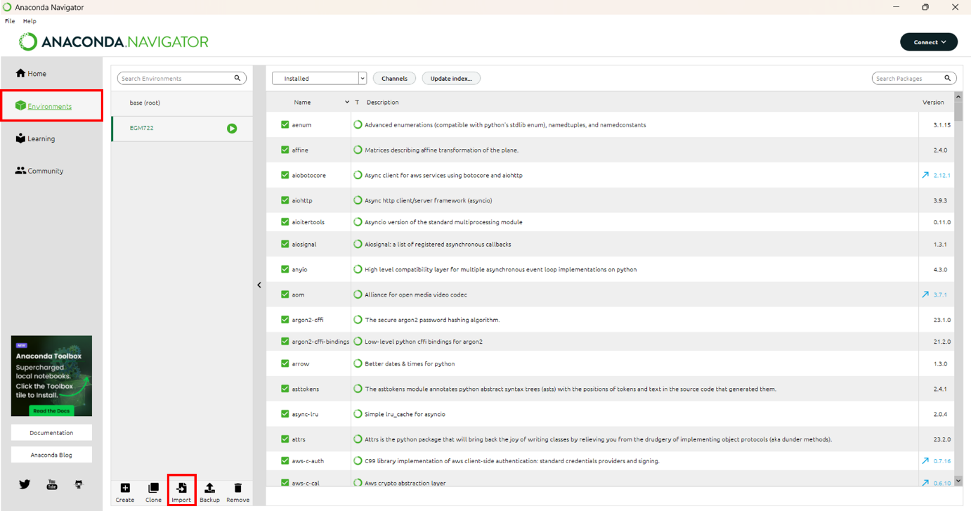

Figure 1: Environments tab of Anaconda Navigator with environments tab and import button highlighted in red.

Next click on the imports tab (fig.1) and select the file ‘environment.yml’ contained in the .zip file of the tool’s download, choosing an appropriate name for the environment (fig.2).

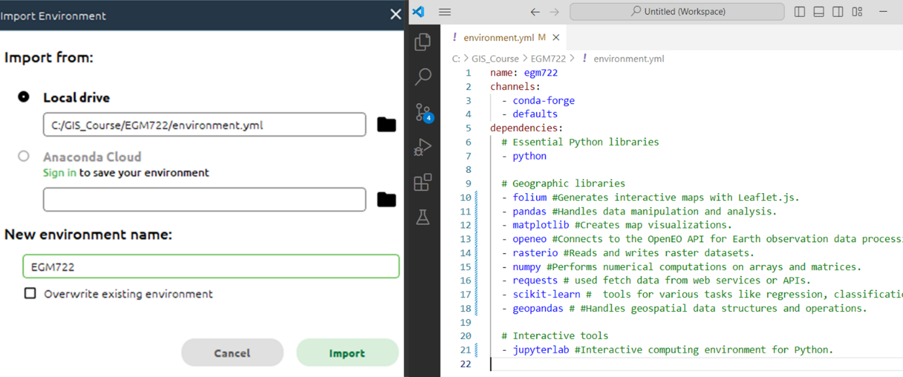

Figure 2: The import config box (left) and the contents of ‘environment.yml’ (right).

Click Import. Depending on the connection speed of your network, the process of installing all the packages may take several minutes. Once finished you will be returned to the environments tab (fig.1)

Next click on the ‘Home’ tab in Anaconda Navigator’s sidebar (fig.3).

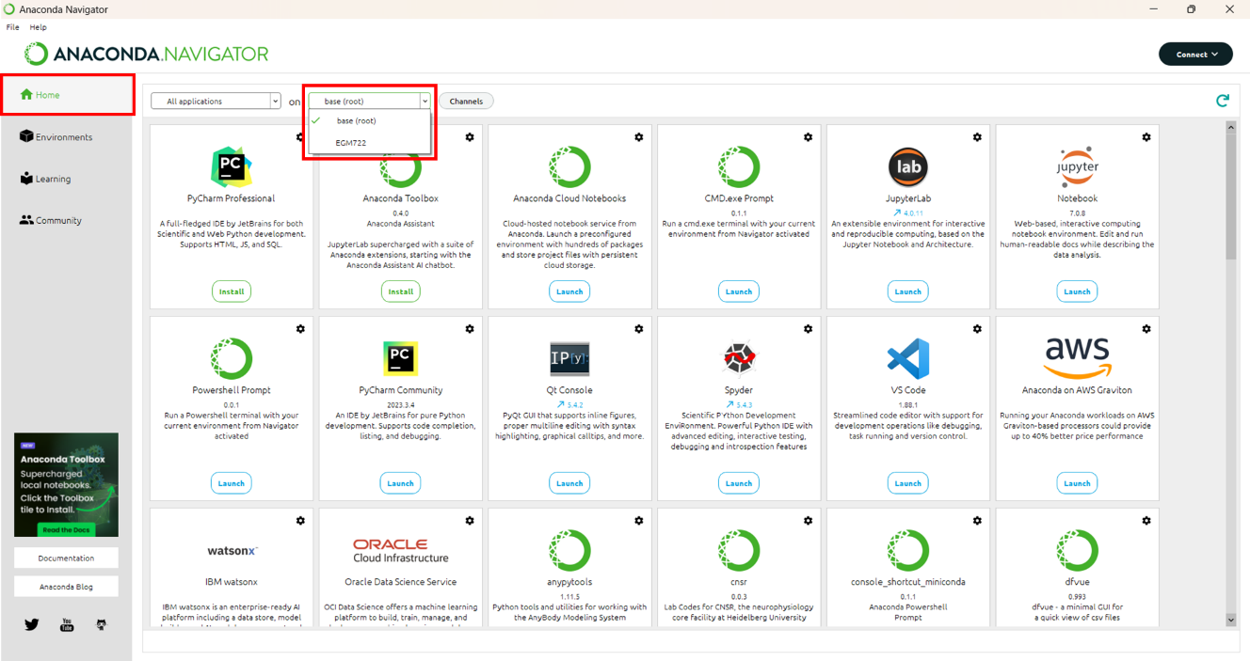

Figure 3: Anaconda Navigator with home tab and environment switching dropdown in red.

The dropdown highlighted in figure 3 should display two options, ‘base (root)’ and the name of your new environment (in figure 3 this is ‘EGM722). **Ensure your environment name is selected here or the dependencies installed earlier will not be available to it.**

## 2.3 Setting up Jupyter Lab

A configuration file (‘.config’) needs to be created to change the settings used by Jupyter Lab by default. Launch the CMD.exe prompt (fig.4)

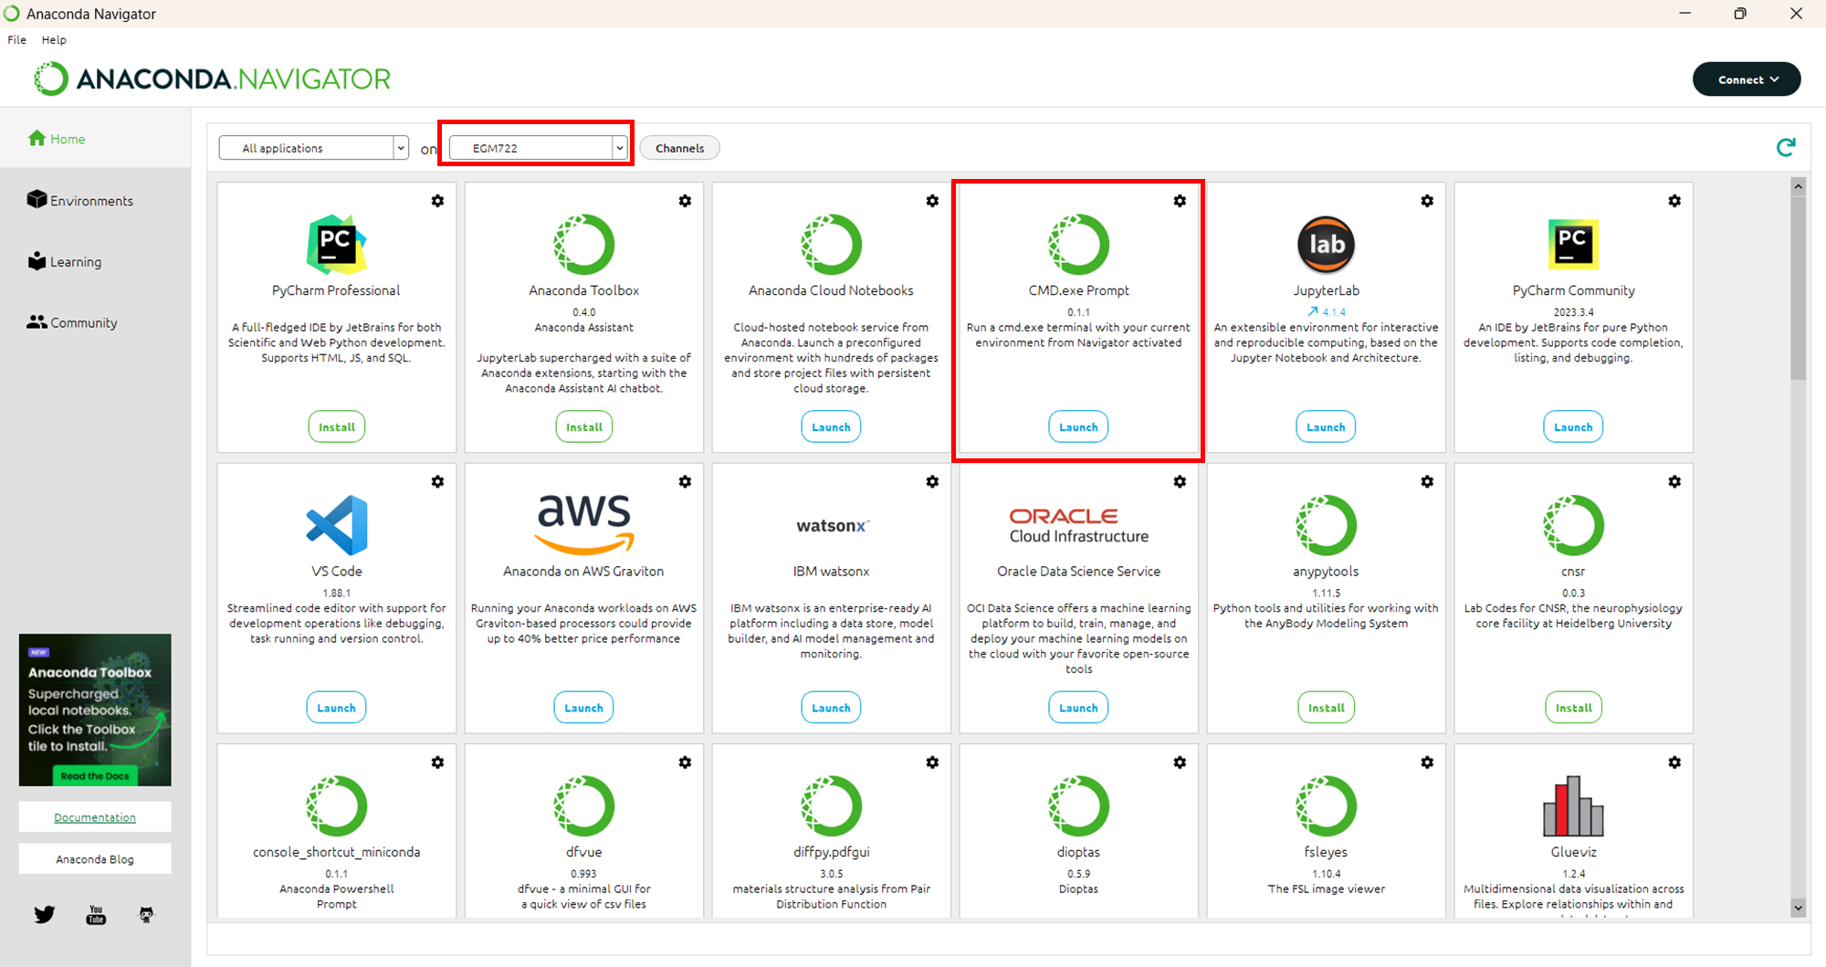

Figure 4: Highlighted locations of selected environment and CMD.exe Prompt

In the command prompt, enter the command:

|  |
| --- |
| jupyter lab --generate-config |

This will create a new folder in your user directory called ‘.jupyter’ containing a python script juptyer_lab_config.py. On Windows this is usually ‘C:\Users\<your_username>’.

Jupyter lab will by default open in your user directory. Unfortunately due to security restrictions it is not possible to navigate to the parent directory of the launch location. So if Jupyter launches in ‘C:\Users\RockyBalboa, it is not possible to move to ‘C:\Users’ or, ‘C:\EGM722’. If the directory you are keeping your data in is outside your user directory, you will need to change the default opening folder to your data directory.

This location is also where you should store the following files and folder:

* Sentinel_5P_Atmospheric_Gas_Time_Series.ipynb
* Sentinel_5P_Atmospheric_Gas_Map.ipynb
* Sentinel_2_CH4_Multi-Band-Multi-Pass.ipynb
* The folder “Data”

If your data directory is in your user directory, you should be able to click and navigate there using the interface of Jupyter Lab. If that is not the case, you will need to do the following:

Open an Anaconda Navigator CMD.exe prompt and type the following command:

|  |
| --- |
| jupyter --paths |

This will show something like figure 5 although your file paths will be unique to you.

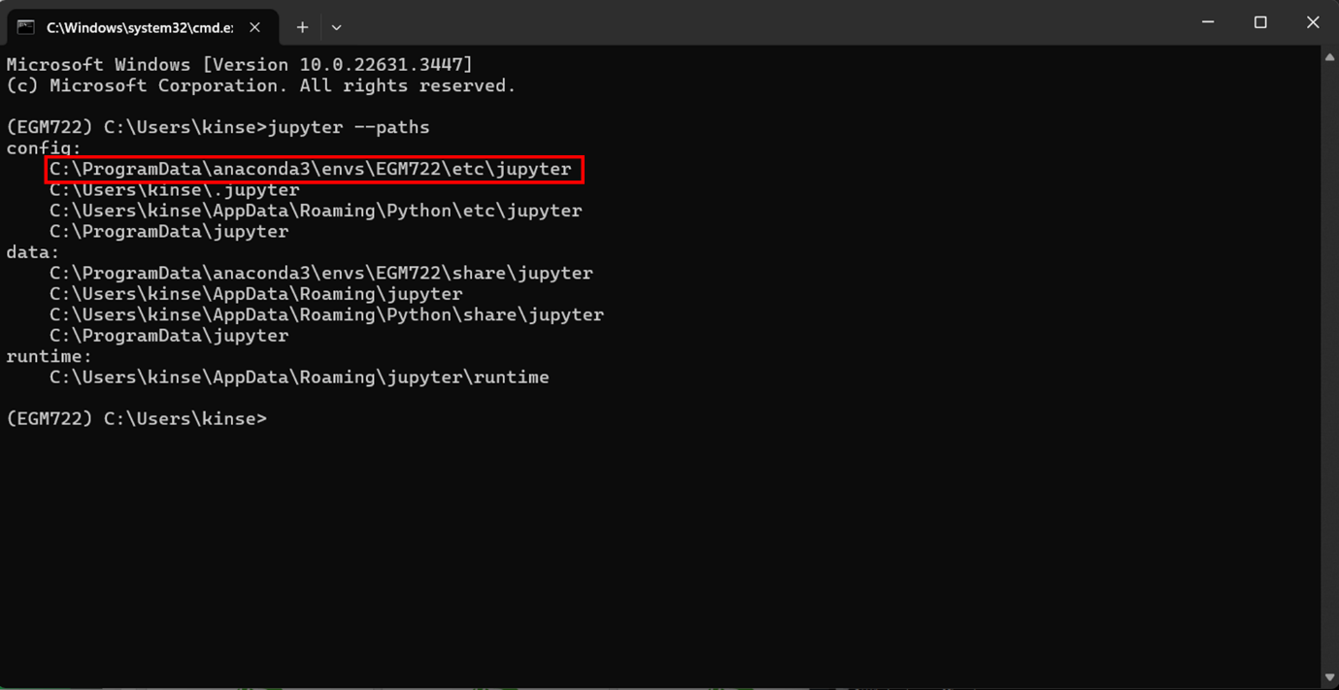

Figure 5: results of ‘jupyter –paths’ command showing path used by environment highlighted in red.

The ‘jupyter_lab_config.py’ file mentioned earlier needs to be copy pasted into that folder.

Once ‘jupyter_lab_config.py’ file has been moved, open it in Notepad++, Visual Studio Code or if you don’t have those, Notepad. Using the shortcut ‘CTRL + F’ type in the following line: ‘c.ServerApp.root_dir’ (without quotes) and you should find the section highlighted in figure 6.

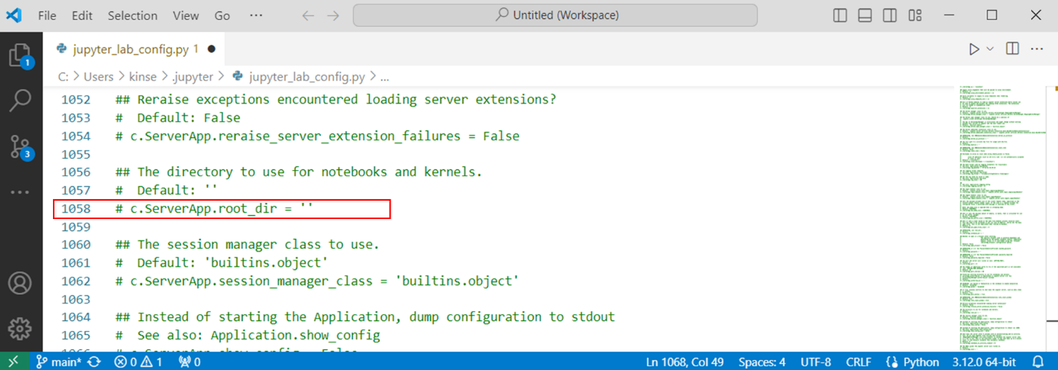

Figure 6: location of 'c.ServerApp.root_dir' in jupyter_lab_config.py

Remove the ‘#’ and space from the start and add the path used by your environment between the quote marks, adding a ‘r’ beforehand (fig.7).

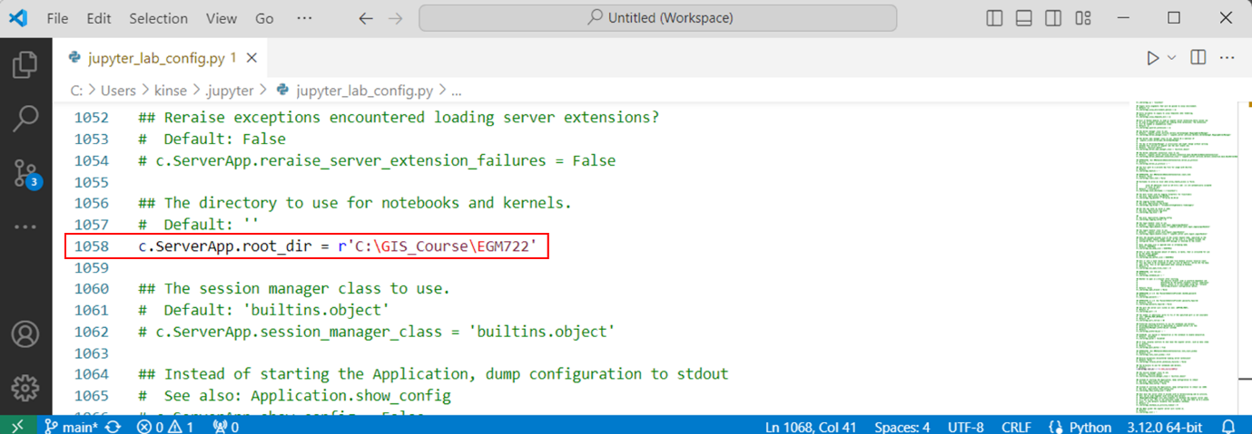

Figure 7: path to data directory added to jupyter_lab_config.py

Save and close this file and return to the Anaconda Navigator ‘Home’ tab. Launch Jupyter Lab and if you have followed the steps correctly, you should see that your data directory is automatically displayed (figure 8).

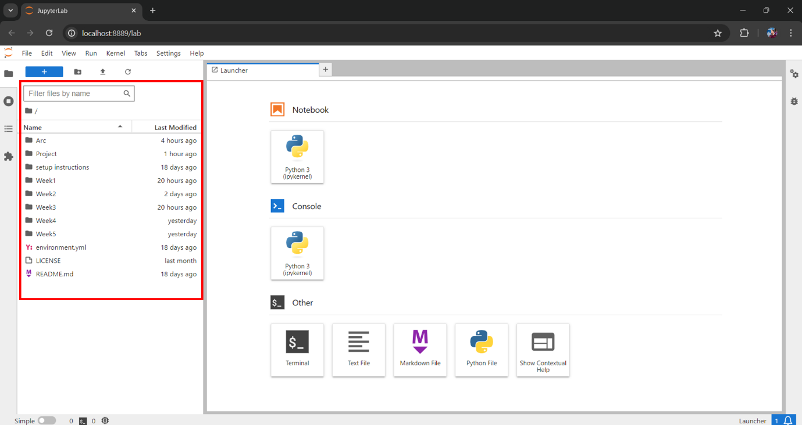

Figure 8: Jupyter Lab showing by default the data directory

## 2.4 OpenEO setup using Anaconda Navigator

OpenEO is an open-source API that allows access to the earth observation satellite missions run by the Copernicus program. These include the satellites used by this tool.

First search in the Anaconda Navigator environments tab for ‘openeo’. Make sure that ‘Not installed’ is selected (fig.9). If the package appears here, click its tick box and select apply. If you can’t see it here, please go to section 2.5.

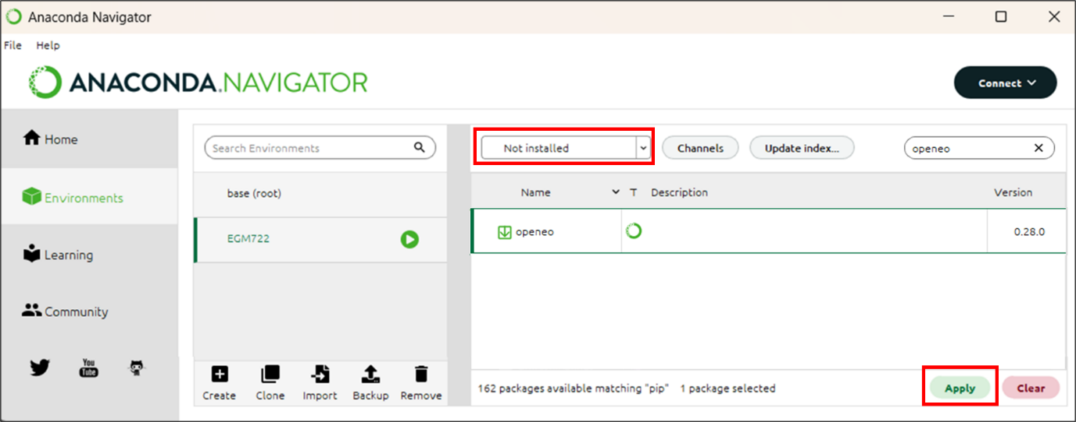

Figure 9: installing OpenEO from Anaconda Navigator.

Next you will be presented with the following screen (fig.10). One this has finished processing the request. Simply click ‘apply’ to begin the installation.

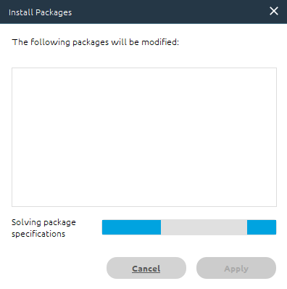

Figure 10: Anaconda Navigator package installer loading screen.

## 2.5 OpenEO setup using PyPi

If Anaconda Navigator cannot find OpenEO you can use PyPi, the official third-party software library for Python. Search for ‘pip’, selecting the appropriate tick-box and then clicking apply (fig.11), then clicking apply once the install packages prompt has finished loading (fig.10).

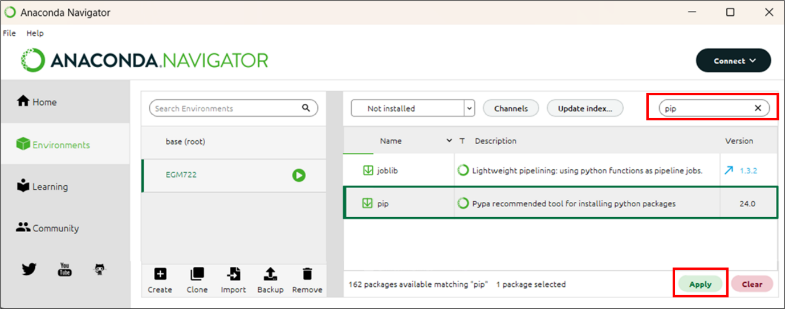

Figure 11: Installing pip via Anaconda Navigator

Open an Anaconda Navigator CMD.exe prompt and type the following command:

|  |
| --- |
| pip install openeo |

Once the resultant process has completed, you can close the CMD.exe prompt window.

## 2.6 Registering with Copernicus Data Space Ecosystem.

Accessing and analysing OpenEO data requires an authentication. To do this, you need to complete a Copernicus Data Space Ecosystem Registration. Go to https://dataspace.copernicus.eu/ and click the green login button (fig.12)

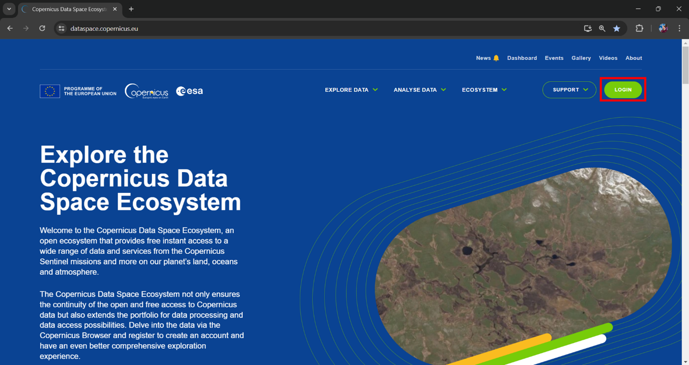

Figure 12: Copernicus Dataspace landing page with login button highlighted in red.

Next click the green ‘register’ button (figure 13):

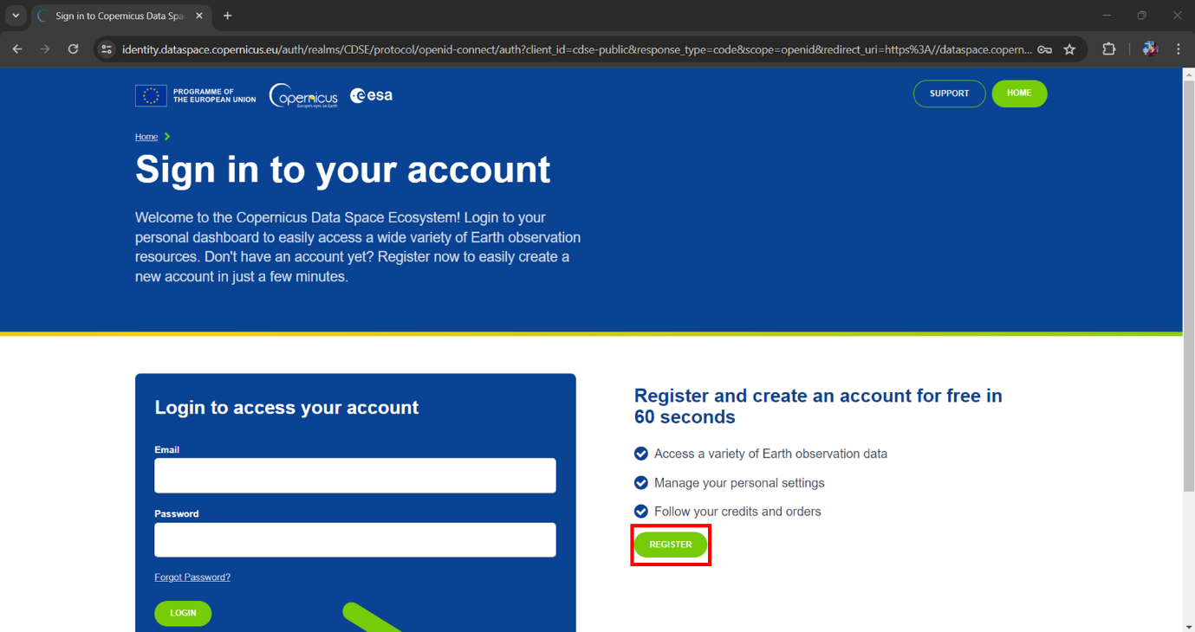

Figure 13: Copernicus Dataspace sign in page.

On the following page, fill out the application form and then at the bottom click the green ‘register’ button (fig.14).

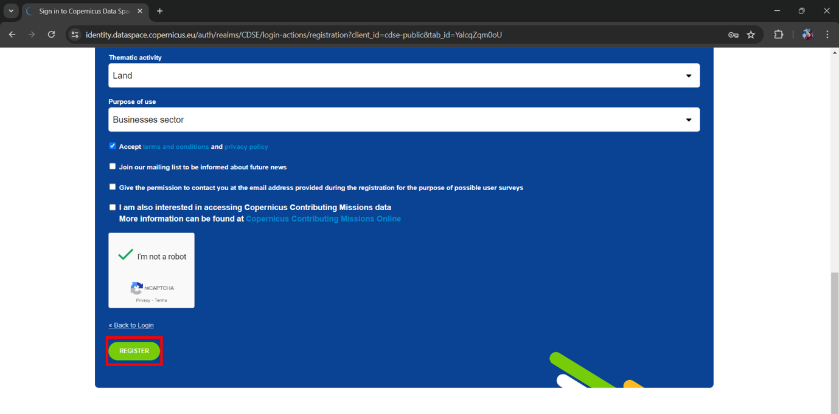

Figure 14: End of Copernicus registration page with register button highlighted in red.

Once registered, you will receive an email asking to verify your address. You can then log-in with your email and chosen password.

For any registration problems, email: <help-login@dataspace.copernicus.eu>

## 2.7 Running the tools in Jupyter-lab

Now that (almost) everything has been setup you can launch Jupyter Lab in the Anaconda Navigator (figure 15). Remember as always that your project environment (here ‘EGM722’) should be selected and not ‘base (root)’.

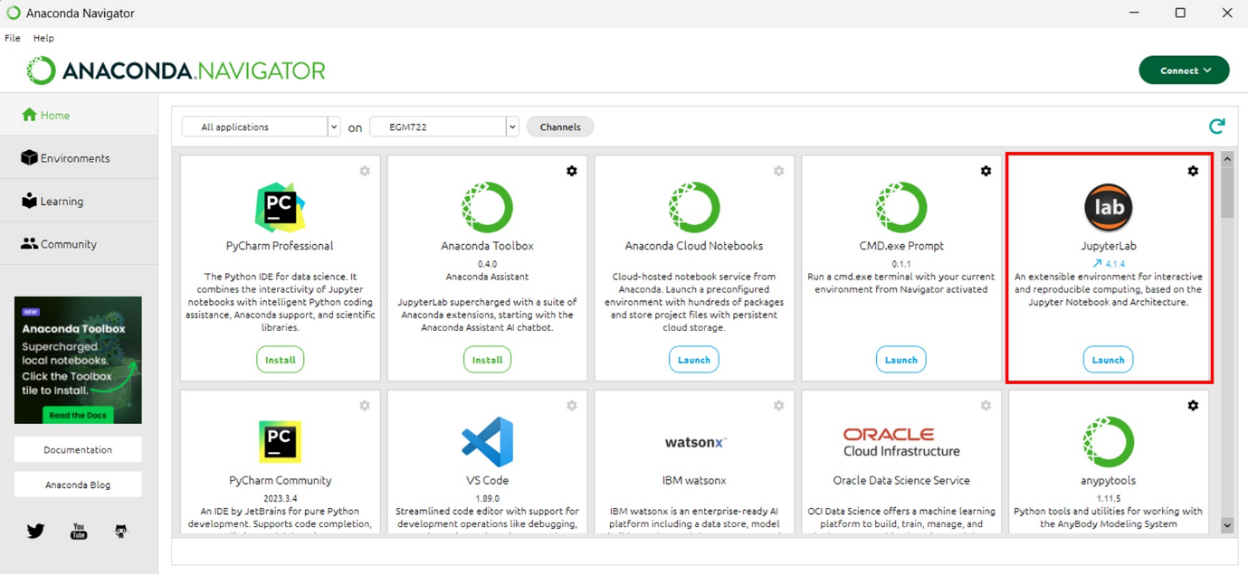

Figure 15: Location of Jupyter Lab in Anaconda Navigator highlighted in red.

Once Jupyter lab opens, you should see the three tools on the left (figure 16).

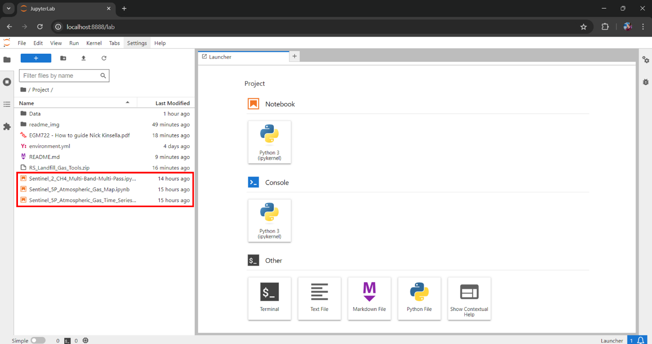

Figure 16: Location of tool scripts in Jupyter lab highlighted in red.

Click on one of the tools to open it. You can then follow the instructions, running the code by clicking the play button (figure 17).

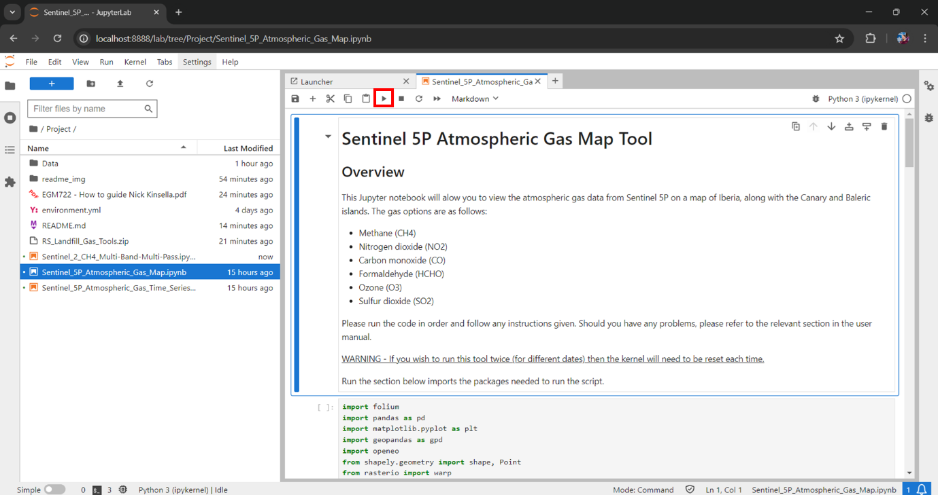

Figure 17: Location of the ‘play’ button which runs each of the code segments of the workbooks.

## 2.8 Authentication with OpenEO

The very first time one of the tools are run, the following section of code…

|  |
| --- |
| connection = openeo.connect(url="openeo.dataspace.copernicus.eu") |
| connection.authenticate_oidc() |

… will provide you with a URL that will look something like this:

|  |
| --- |
| Visit https://auth.example.com/device?user_code=EAXD-RQXV to authenticate. |

Copy this into your web browser and login using the Copernicus Data Space. Once this is complete, run tool’s Python script again and it will receive an authentication token, printing the message:

|  |
| --- |
| Authorized successfully. |

In future you may be prompted with a new URL to create a new authentication token, whereby you should repeat the steps of this section.

# 3. Data and Dependencies

The datasets used by these tools are outlined in table 1.

Table 1: Datasets used by tools

|  |  |  |  |
| --- | --- | --- | --- |
| Description | Data | Source | For use in tool(s) |
| PreZero Landfill Locations | Vector, point | PreZero International. | S5-AGT, S5-AGM |
| PreZero Landfill Bounding | Long/Lat .csv file, point | PreZero Landfill Locations pre-processed. | S2-MBMP |
| Sentinel 5P (TROPOMI) total columns of CO, HCHO, NO2, O3, SO2 and CH4 | Raster  4,518m x 3,552m | Copernicus Dataspace – OpenEO. | S5-AGT, S5-AGM |
| Sentinel 2 (MSI) bands 2, 3, 4 and 12 | Raster 20m2 | Copernicus Dataspace – OpenEO. | S2-MBMP |

The dependencies contained in the environment.yml file are outlined in table 2.

Table 2: dependencies required to use the tools.

|  |  |  |
| --- | --- | --- |
| Name | Description | For use in tool(s) |
| Python | Programming language to run the code | S5-AGTS, S5-AGM & S2-MBMP |
| Folium | Generates interactive maps with Leaflet.js. | S5-AGTS & S5-AGM |
| Pandas | Data manipulation and analysis. | S5-AGTS, S5-AGM & S2-MBMP |
| Geopandas | Geospatial data manipulation and analysis. | S5-AGTS & S5-AGM |
| Matplotlib | Creates map visualizations | S5-AGTS, S5-AGM & S2-MBMP |
| Rasterio | Reads and edits raster datasets. | S5-AGM & S2-MBMP |
| Numpy | Performs numerical computations on arrays | S5-AGTS, S5-AGM & S2-MBMP |
| Requests | Used fetch data from web services or APIs. | S2-MBMP |
| Scikit-learn | Linear regression for brightness correction | S2-MBMP |
| OpenEO | API for Earth observation data processing | S5-AGT, S5-AGM & S2-MBMP |

# 4. Methodology

## 4.1 Sentinel-5 Atmospheric Gas Timeseries:

This tool creates a timeseries graph of gas concentrations for selected landfills, identifying high concentration days using average concentration in a 10km buffer. It is based on a Python notebook from Copernicus OpenEO (2024), modified to use Sentinel 5 data and PreZero’s landfill locations. Despite Sentinel 5’s low spatial resolution, it provides daily measurements of several gases, useful for studying transient atmospheric phenomena like methane emissions (Varon et al., 2021). The processing steps are presented in Figure 15 and the code thereafter.

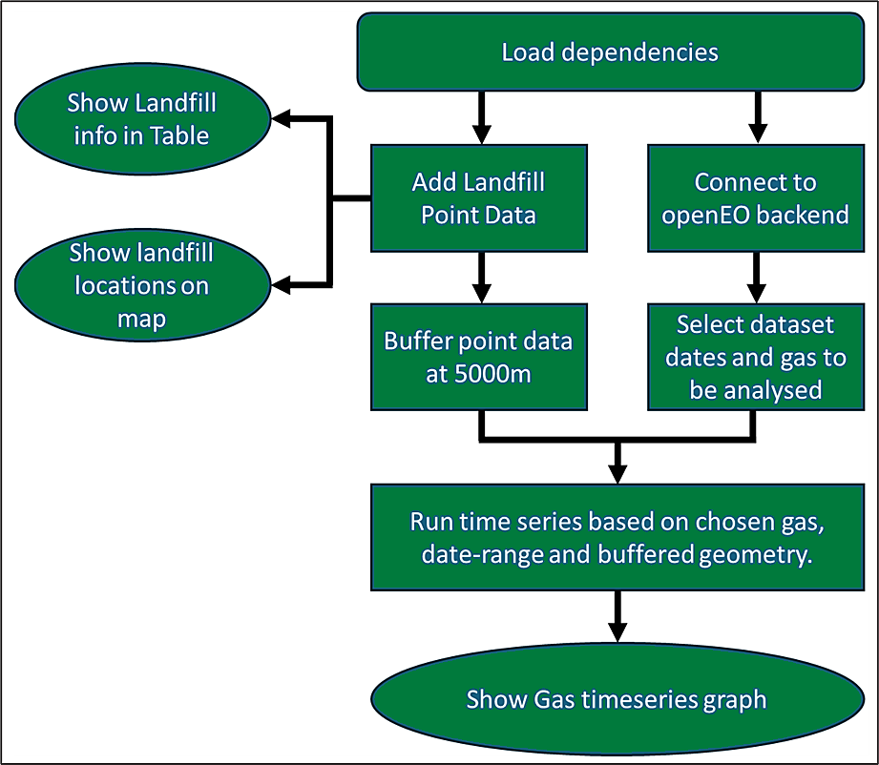

Figure 18: Flowchart of processes used for Gas timeseries analysis.

Code 1 loads the dependencies for the tool to run.

|  |
| --- |
| import folium |
| import pandas as pd |
| import matplotlib.pyplot as plt |
| import scipy.signal |
| import numpy as np |
| import geopandas as gpd |
| import openeo |
| from shapely.geometry import shape |

Code 1: Loading of dependencies for the code to run.

Code 2 connects to the OpenEO backend.

|  |
| --- |
| connection = openeo.connect(url="openeo.dataspace.copernicus.eu") |
| connection.authenticate_oidc() |

Code 2: Connecting to OpenEO

Code 3 uses geopandas to read a .geojson file that contains point vector data of the landfill location and then displays it for the end user to see.

|  |
| --- |
| landfills = gpd.read_file(r"C:\GIS_Course\EGM722\Project\Data\PZ_landfill_point4326.geojson") |
| landfills |

Code 3: Displaying the contents of the landfill file for easy reference.

Code 4 shows the locations of the landfills on a map using folium. The user can click on a map pin to view the landfill’s address. The map is centred on the loaded geometries by calculating the average x and y location of all the datapoints.

|  |
| --- |
| # This creates the map and centres it on the dataset’s centre point. |
| centroids = landfills.geometry.centroid |
| centre = [centroids.y.mean(), centroids.x.mean()] |
| site_map = folium.Map(location=centre, zoom_start=5) |
|  |
| # Adding the landfill locations to the map |
| for feature in landfills.iterfeatures(): |
| # Extract feature number from properties |
| feature_number = feature['properties']['Landfill'] |
|  |
| # Extract coordinates of the feature |
| coordinates = feature['geometry']['coordinates'] |
|  |
| # Create a marker with label for each feature |
| folium.Marker(location=[coordinates[1], coordinates[0]], |
| popup=f"Feature {feature_number}").add_to(site_map) |
|  |
| # Display the map |
| site_map |

Code 4: Code for displaying the landfill points on a map for easy reference.

Code 5 adds a buffer of 10,000 metres to the landfill point data, and then formats it as a .geojson, as the OpenEO API requires it in that format.

|  |
| --- |
| # loading dataframe |
| landfill_10000m = landfills |
|  |
| # The dataset is projected in EPSG:4326 with its units in degrees. This needs to be converted to CRS to EPSG:2062, which is in metres. |
| landfill_10000m = landfill_10000m.to_crs(epsg=2062) |
|  |
| # Now the dataframe is converted, a buffer of 5000m is added to each point |
| landfill_10000m['geometry'] = landfill_10000m.buffer(10000) |
|  |
| # Now the buffered data needs to be converted back to EPSG:4326 because the Sentinel data is projected in EPSG:4326. |
| landfill_10000m = landfill_10000m.to_crs(epsg=4326) |
|  |
| # The time series analysis requires that A GeoJSON format file is used for the analised areas, so this bit produces a file suitable for that. |
| landfill_10000m_geojson = landfill_10000m.__geo_interface__ |

Code 5: Code for adding buffers to landfill point data

Code 6 selects the specific dataset for the time series analysis, including the date range and gas type.

|  |
| --- |
| s5cube_timeseries = connection.load_collection( |
| "SENTINEL_5P_L2", |
| temporal_extent=["2021-08-01", "2021-10-31"], # format YYYY-MM-DD |
| bands=["CH4"], # Gas options 'CO', 'HCHO', 'NO2', 'O3', 'SO2', 'CH4' |
| ) |

Code 6: Selecting date for time series and gas to be monitored.

Code 7 runs the time series analysis and saves the results as a .csv file. This process can take several minutes depending on how much time has been selected in the temporal extent.

|  |
| --- |
| timeseries = s5cube_timeseries.aggregate_spatial(geometries=landfill_5000m_geojson, reducer="mean") |
|  |
| #This saves the results as a .CSV file which can be viewed in Microsoft Excel or a similar package. It will be saved in the indicated location. |
| job = timeseries.execute_batch(out_format="CSV", title="Gas timeseries") |
|  |
| job.get_results().download_file("Gas_Timeseries_results/Gas_timeseries.csv") |
|  |
| pd.read_csv("Gas_Timeseries_results/Gas_timeseries.csv", index_col=0) |

Code 7: Running the data collection for the time series.

Code 8 plots the data on a timeseries graph using much of the script taken from the NDVI OpenEO notebook (OpenEO, 2024). Modifications include scaling the value of the Y axis to whatever data is loaded and allowing the user to select which landfills they want to view on the graph.

|  |
| --- |
| def plot_timeseries(filename, selected_landfill_ids=None, figsize=(15, 10)): |
| df = pd.read_csv(filename, index_col=0) |
| df.index = pd.to_datetime(df.index) |
| df = df.sort_index() |
|  |
| fig, ax = plt.subplots(figsize=figsize, dpi=90) |
|  |
| if selected_landfill_ids: |
| df_selected = df[df['feature_index'].isin(selected_landfill_ids)] |
| for landfill_id, group in df_selected.groupby("feature_index"): |
| group["avg(band_0)"].plot(marker="o", label=f"Landfill {landfill_id}", ax=ax) |
| else: |
| df.groupby("feature_index")["avg(band_0)"].plot(marker="o", ax=ax) |
|  |
| ax.set_title(filename.split("/")[-1]) |
| ax.set_ylabel("Parts per billion for CH4 or mol/m2 for all other gases") |
|  |
| ymin = df["avg(band_0)"].min() |
| ymax = df["avg(band_0)"].max() |
| ymin_with_margin = ymin - 0.1 * (ymax - ymin) |
| ymax_with_margin = ymax + 0.1 * (ymax - ymin) |
| ax.set_ylim(ymin_with_margin, ymax_with_margin) |
|  |
| ax.legend(title="Landfill id", loc='upper left', bbox_to_anchor=(1.02, 1), ncol=2) |
| ax.xaxis.set_major_locator(plt.MaxNLocator(30)) |
| ax.grid(True) |
|  |
| # Change the selected landfill ids for the ones you want to view. |
| plot_timeseries("Gas_Timeseries_results/Gas_timeseries.csv", |
| selected_landfill_ids=[13, 14, 15, 16, 17, 18 ,19, 20, 21, 22, 23]) |

Code 8: For plotting the time series data on a graph

## 4.2 Sentinel-5 Atmospheric Gas Concentration Map:

The tool makes a map of atmospheric gas concentrations over the Iberian peninsula, the Balearic and Canary islands, with marked locations for where PreZero has its landfills. This allows the user to continue their analysis based on the results of the time series. As a high concentration signal could be generally elevated levels in the atmosphere, or it could be a landfill emission. Figure 16 provides an overview of the main steps in processing.

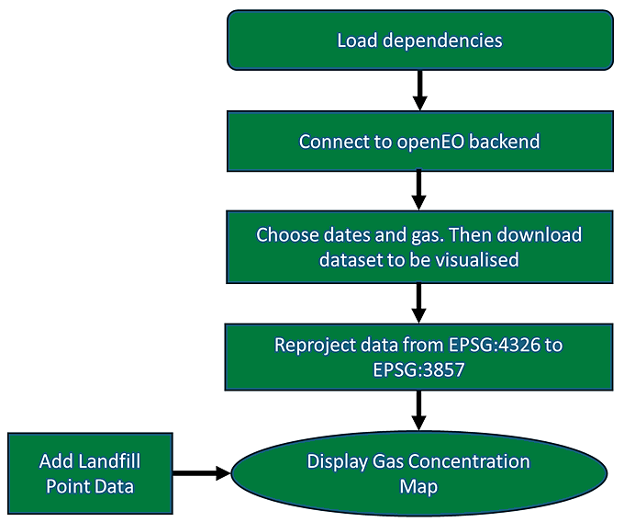

Figure 19: Flowchart of processes used for Gas Concentration Map

Code 9 shows the dependencies that are loaded.

|  |
| --- |
| import folium |
| import pandas as pd |
| import matplotlib.pyplot as plt |
| import geopandas as gpd |
| import openeo |
| from shapely.geometry import shape, Point |
| from rasterio import warp |
| from matplotlib import cm |
| from matplotlib.colors import Normalize |
| import folium.raster_layers |
| import rasterio |
| from rasterio import warp |
| import numpy as np |

Code 9: Loading of dependencies for the code to run.

Code 10 connects to the OpenEO backend.

|  |
| --- |
| connection = openeo.connect(url="openeo.dataspace.copernicus.eu") |
| connection.authenticate_oidc() |

Code 10: Connecting to OpenEO

Code 11 selects the specific date to be viewed and what gas is to be monitored. It then downloads it as a .GTiff file.

|  |
| --- |
| cube = connection.load_collection( |
| collection_id="SENTINEL_5P_L2", |
| temporal_extent=["2023-06-01", "2023-06-01"], # format YYYY-MM-DD. Only one date should be selected so the to and from fields should be identical. |
| spatial_extent={"west": -19.5, "south": 27.0, "east": 5.0, "north": 44.5}, |
| bands=["CH4"], Gas monitoring options: 'CO', 'HCHO', 'NO2', 'O3', 'SO2', 'CH4' |
| )  cube.download("Sentinel-5P_Spain.GTiff") |

Code 11: Code for selecting dates and gas, then downloading the data.

Code 12 takes the Sentinel-5P_Spain.GTiff file and reprojects its CRS from EPSG:4326 to EPSG:3857, the projection of the folium map.

|  |
| --- |
| dst_crs = 'EPSG:3857' |
|  |
| # Open the gas data file that is in EPSG:4326 and calculate its bounds |
| with rasterio.open('Sentinel-5P_Spain.GTiff') as src: |
| transform, width, height = rasterio.warp.calculate_default_transform( |
| src.crs, dst_crs, src.width, src.height, *src.bounds) |
| # Copy and update the metadata from the source dataset |
| kwargs = src.meta.copy() |
| kwargs.update({ |
| 'crs': dst_crs, |
| 'transform': transform, |
| 'width': width, |
| 'height': height |
| }) |
| # Create a new gas data file in EPSG:3857 |
| with rasterio.open('Sentinel-5P_Spain3857.GTiff', 'w', **kwargs) as dst: #if you wish to run this without restarting the kernel, you will need to rename this |
| # Loop through each band in the source dataset |
| for ind in range(1, src.count + 1): |
| # Reproject each band and write it to the destination dataset |
| rasterio.warp.reproject( |
| source=rasterio.band(src, ind), |
| destination=rasterio.band(dst, ind), |
| src_transform=src.transform, |
| src_crs=src.crs, |
| dst_transform=transform, |
| dst_crs=dst_crs, |

Code 12: Code for reprojecting raster

Code 13 loads the folium map. The pins are clickable for the landfill information and the map is centred on those features. Because the CH4 dataset is not a continuous raster, a piece of code ignoring those values has been included. The colourmap is then set using the matplotlib library. The raster bounds are set using a west, south, east, north longitude and latitude. Finally the legend bar is set to scale to whatever atmospheric gas dataset is shown on the map.

|  |
| --- |
| # This section loads the map |
|  |
| #This is the reprojected gas data |
| gas_data = r'C:\GIS_Course\EGM722\Project\Sentinel-5P_Spain3857.GTiff' |
|  |
| # Open raster file, load values and prepare them to be displayed. |
| dataset = rasterio.open(gas_data, 'r') |
| rasdata = dataset.read()[0] |
| rasdata_normed = rasdata / rasdata.max() * 10 |
|  |
| # When the data is displayed, this says to ignore values of zero. |
| non_zero_values = rasdata[rasdata != 0] |
| min_value = non_zero_values.min() |
| max_value = non_zero_values.max() |
| normalized_data = (non_zero_values - min_value) / (max_value - min_value) |
|  |
| # Create a colourmap for the non-zero values |
| colourmap = cm.turbo |
| colourmap_index = np.zeros_like(rasdata, dtype=np.float64) |
| colourmap_index[rasdata != 0] = normalized_data |
|  |
| #Loading in the landfill locations |
| PZ_landfill_Locations = gpd.read_file(r"C:\GIS_Course\EGM722\Project\Data\PZ_landfill_point4326.geojson") |
|  |
| # This creates the map and centres it on the geometries. |
| centroids = PZ_landfill_Locations.geometry.centroid |
| center = [centroids.y.mean(), centroids.x.mean()] |
| gas_concentration_map = folium.Map(location=center, zoom_start=5, tiles='CartoDB Positron') |
|  |
| # Adding the PreZero landfill locations to the map and making them clickable for info |
| for feature in PZ_landfill_Locations.iterfeatures(): |
| # Extract feature number from properties |
| feature_number = feature['properties']['Landfill'] |
| # Extract coordinates of the feature |
| coordinates = feature['geometry']['coordinates'] |
| # Create a marker with label for each feature |
| folium.Marker(location=[coordinates[1], coordinates[0]], |
| popup=f"Feature {feature_number}").add_to(gas_concentration_map) |
|  |
| # Adding the gas concentration dataset to the map |
| folium.raster_layers.ImageOverlay( |
| image=colourmap(colourmap_index), |
| name='gas concentration in atmosphere', |
| opacity=0.6, |
| bounds=[[27.0, -19.5], [44.4, 5.0]],  # this should be the same as the spatial extent of cube |
| interactive=False, |
| cross_origin=False, |
| zindex=1 |
| ).add_to(gas_concentration_map) |
|  |
| # Creating the legend for gas concentration |
| fig, ax = plt.subplots(figsize=(8, 0.2)) |
| cbar = plt.colorbar(cm.ScalarMappable(norm=Normalize(vmin=min_value, vmax=max_value), |
| cmap=colourmap), |
| cax=ax, orientation='horizontal') |
| cbar.set_label('Parts per billion for CH4 or mol/m2 for all other gasses') |
|  |
| # Display the map |
| gas_concentration_map |

Code 13: Code for configuring and loading Gas Concentration Map

## 4.3 Sentinel-2 Multi-Band-Multi-Pass CH4 Map:

Sentinel 5’s resolution is very coarse, so to help users detect emission locations on a landfill, Sentinel 2’s MSI instrument with a 20m2 spatial resolution and return frequency of 3-5 days was employed to detect provide higher definition images of CH4 levels over their landfills. Figure 17 provides an overview of the main steps in processing.

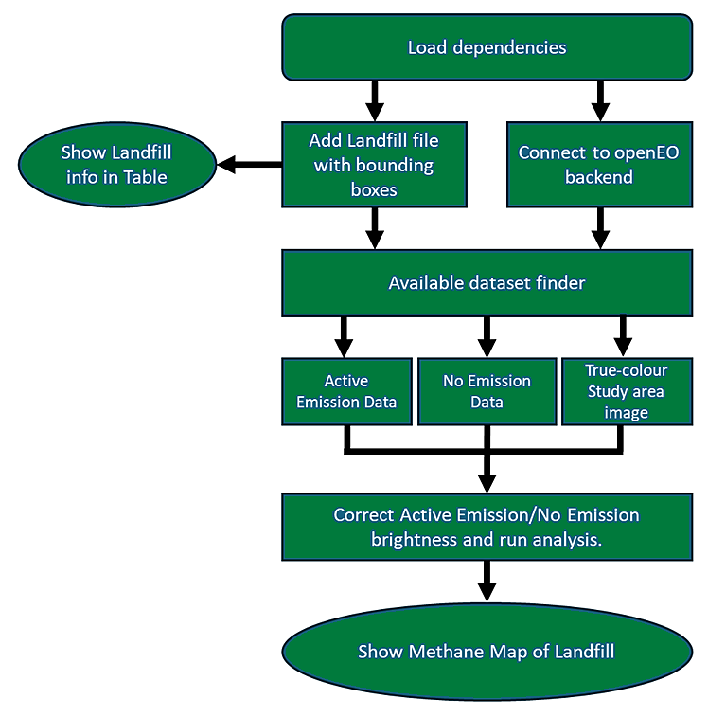

Figure 20: Flowchart of processes used for Sentinel 2 Landfill CH4 Map

Code 14 shows the dependencies that are loaded.

|  |
| --- |
| import folium |
| import pandas as pd |
| import matplotlib.pyplot as plt |
| import openeo |
| import rasterio |
| import numpy as np |
| import requests |
| from sklearn.linear_model import LinearRegression |

Code 14: Loading of dependencies for the code to run.

Code 15 connects to the OpenEO backend.

|  |
| --- |
| connection = openeo.connect(url="openeo.dataspace.copernicus.eu") |
| connection.authenticate_oidc() |

Code 15: Connecting to OpenEO

Code 16 reads a .geojson file that contains the landfill location bounding boxes, and then displays it for the end user to see. There are options for small and large bounding boxes.

|  |
| --- |
| landfill_csv = pd.read_csv(r'C:\GIS_Course\EGM722\Project\Data\PreZero_Landfill_Bounding_small.csv') |
| # landfill_csv = pd.read_csv(r'C:\GIS_Course\EGM722\Project\Data\PreZero_Landfill_Bounding_small.csv') |
| landfill_csv |

Code 16: Displaying the contents of the landfill file for easy reference.

Code 17 provides the available datasets for a date range and landfill selected by the user. It also has a cloud filter set at 15% as excessive cloud can interfere with the tool.

|  |
| --- |
| def get_spatial_extent(landfill_id): |
| landfill = landfill_csv[landfill_csv['id'] == landfill_id].iloc[0] |
| return { |
| "west": landfill['west'], |
| "south": landfill['south'], |
| "east": landfill['east'], |
| "north": landfill['north'] |
| } |
| def fetch_available_dates(landfill_id, temporal_extent): |
| spatial_extent = get_spatial_extent(landfill_id) |
| catalog_url = f"https://catalogue.dataspace.copernicus.eu/resto/api/collections/Sentinel2/search.json?box={spatial_extent['west']}%2C{spatial_extent['south']}%2C{spatial_extent['east']}%2C{spatial_extent['north']}&sortParam=startDate&sortOrder=ascending&page=1&maxRecords=1000&status=ONLINE&dataset=ESA-DATASET&productType=L2A&startDate={temporal_extent[0]}T00%3A00%3A00Z&completionDate={temporal_extent[1]}T00%3A00%3A00Z&cloudCover=%5B0%2C{cloud_cover}%5D" |
| response = requests.get(catalog_url) |
| response.raise_for_status() |
| catalog = response.json() |
| dates = [date.split('T')[0] for date in map(lambda x: x['properties']['startDate'], catalog['features'])] |
| return dates |
|  |
| # Please enter your parameters here. |
| landfill_id = 23  # Specify the landfill ID. |
| temporal_extent = ["2023-01-01", "2023-03-12"]  # Specify the the date range you want to c1heck for available data. |
| cloud_cover = 15 |
|  |
| available_dates = fetch_available_dates(landfill_id, temporal_extent) |
| print("Available dates:", available_dates) |

Code 17: Code for determining available dates for analysis.

Code 18 is for designating the active emission dataset. Here the user will select the day that the emission was seen with the S5-AGT tool, along with the appropriate landfill id.

|  |
| --- |
| def active_emission(landfill_id, temporal_extent): |
| landfill = landfill_csv[landfill_csv['id'] == landfill_id].iloc[0] |
|  |
| active_emission = connection.load_collection( |
| "SENTINEL2_L2A", |
| temporal_extent=temporal_extent, |
| spatial_extent={ |
| "west": landfill['west'], |
| "south": landfill['south'], |
| "east": landfill['east'], |
| "north": landfill['north'] |
| }, |
| bands=["B11", "B12"], |
| ) |
| active_emission.download("Sentinel-2_active_emissionMBMP.GTiff") |
|  |
| # Enter perameters for the active emission day |
| landfill_id = 23  # Specify the landfill ID |
| temporal_extent = ["2023-02-25", "2023-02-25"] |
|  |
| active_emission(landfill_id, temporal_extent) |

Code 18: Code for downloading active emission dataset.

Like the code before it, Code 19 is for designating the no emission dataset that will be used to compare to the active emission dataset.

|  |
| --- |
| def no_emission(landfill_id, temporal_extent): |
| landfill = landfill_csv[landfill_csv['id'] == landfill_id].iloc[0] |
| no_emission_collection = connection.load_collection( |
| "SENTINEL2_L2A", |
| temporal_extent=temporal_extent, |
| spatial_extent={ |
| "west": landfill['west'], |
| "south": landfill['south'], |
| "east": landfill['east'], |
| "north": landfill['north'] |
| }, |
| bands=["B11", "B12"], |
| ) |
| no_emission_collection.download("Sentinel-2_no_emissionMBMP.GTiff") |
| # Enter parameters for the no emission day |
| landfill_id = 23  # Specify the landfill ID |
| temporal_extent = ["2023-02-10", "2023-02-10"] |
|  |
| no_emission(landfill_id, temporal_extent) |

Code 19: Code for downloading no emission dataset.

Finally, as with the two codes before, Code 20 downloads a true colour satellite image to aid in the visualisation of the data.

|  |
| --- |
| def truecolour_image(landfill_id, temporal_extent): |
| landfill = landfill_csv[landfill_csv['id'] == landfill_id].iloc[0] |
| truecolour_image_collection = connection.load_collection( |
| "SENTINEL2_L2A", |
| temporal_extent=temporal_extent, |
| spatial_extent={ |
| "west": landfill['west'], |
| "south": landfill['south'], |
| "east": landfill['east'], |
| "north": landfill['north'] |
| }, |
| bands=["B02", "B03", "B04"], |
| ) |
| truecolour_image_collection.download("Sentinel-2_truecolour.GTiff") |
| # Enter parameters for the no emission day |
| landfill_id = 23  # Specify the landfill ID |
| temporal_extent = ["2023-02-22", "2023-02-22"] |
|  |
| truecolour_image(landfill_id, temporal_extent) |

Code 20: Code for downloading true colour satellite image for data visualisation

The next code runs the analysis following the multi-band-multi-pass retrieval method employed by Varon et al. (2021), albeit without their radiative transfer model, which was unfortunately not provided in the paper. The authors of the paper have been contacted, and this code can be added in the future. The code begins with a multi-band-single-pass calculation for both active emission and no emission dates, resulting in two datasets.

The multi-band-single-pass equation is as follows:

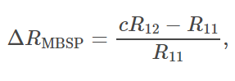

Where:

* c is calculated using a least-squares fitting algorithm of R12 against R11.
* R12 is the Sentinel-2 SWIR-2 band (“B12” in the code).
* R11 is the Sentinel-2 SWIR-1 band (“B11” in the code).

To calculate the correction factor ‘c’ a Python code developed by Amazon Web Services for a similar CH4 model was used (AWS, 2023). The process is as follows:

* ‘compute_correction_factor’ performs a linear least square regression using the SWIR-2 and SWIR-1 datasets from both active and no emission .Gtiff files.
* ‘compute_corrected_fractional_reflectance_change’ applies the computed correction factor and applies it to the active emission scene (R12) to give cR12.

Once the multi-band-single-pass has been calculated for both active emission and no emission dates, the no emission scene is subtracted from the active emission scene:

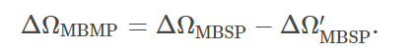

Where ΔΩMBSP is the multiband single pass for the active emission scene and ΔΩ′MBSP is the multiband single pass for the no emission scene.

|  |
| --- |
| # Opening the datasets to be used for the analysis |
| Active_Multiband = "Sentinel-2_active_emissionMBMP.GTiff" |
| Active_img = rasterio.open(Active_Multiband) |
| Active_B11 = Active_img.read(1) |
| Active_B12 = Active_img.read(2) |
|  |
| No_Multiband = "Sentinel-2_no_emissionMBMP.GTiff" |
| No_img = rasterio.open(No_Multiband) |
| No_B11 = No_img.read(1) |
| No_B12 = No_img.read(2) |
|  |
| # Multi band Single Pass Active Emission |
| def active_compute_correction_factor(Active_B12, Active_B11): |
| # get flattened arrays for regression |
| yB12 = Active_B12.flatten() |
| xB11 = Active_B11.flatten() |
|  |
| assert yB12.shape == xB11.shape, "Shapes of two provided arrays are incompatible!" |
|  |
| # fit linear model using least squares regression |
| xB11 = xB11[:, np.newaxis] |
| c, _, _, _ = np.linalg.lstsq(xB11, yB12, rcond=None) |
|  |
| return c[0] |
|  |
| def active_compute_corrected_fractional_reflectance_change(Active_B12, Active_B11): |
| # get correction factor |
| c = active_compute_correction_factor(Active_B12, Active_B11) |
|  |
| # get corrected fractional reflectance change |
| active_frac_change = ((c * Active_B12 - Active_B11) / Active_B11) |
|  |
| return active_frac_change |
|  |
| # Open raster files |
| with rasterio.open(r"C:\GIS_Course\EGM722\Project\Sentinel-2_active_emissionMBMP.GTiff") as B12_active_emission_file: |
| B12_active_emission_data = B12_active_emission_file.read(2) |
| with rasterio.open(r"C:\GIS_Course\EGM722\Project\Sentinel-2_active_emissionMBMP.GTiff") as B11_active_emission_file: |
| B11_active_emission_data = B11_active_emission_file.read(1) |
|  |
| # Compute corrected fractional reflectance change |
| active_frac_change = active_compute_corrected_fractional_reflectance_change(B12_active_emission_data, B11_active_emission_data) |
|  |
| # Multi band Single Pass No Emission |
| def no_compute_correction_factor(B12_no_emission_data, B11_no_emission_data): |
| # get flattened arrays for regression |
| yB12 = No_B12.flatten() |
| xB11 = No_B11.flatten() |
|  |
| # replace NaN values with 0 |
| yB12 = np.nan_to_num(yB12) |
| xB11 = np.nan_to_num(xB11) |
| assert yB12.shape == xB11.shape, "Shapes of two provided arrays are incompatible!" |
|  |
| # fit linear model using least squares regression |
| xB11 = xB11[:, np.newaxis] |
| c, _, _, _ = np.linalg.lstsq(xB11, yB12, rcond=None) |
|  |
| return c[0] |
|  |
| def no_compute_corrected_fractional_reflectance_change(No_B12, No_B11): |
| # get correction factor |
| c = no_compute_correction_factor(No_B12, No_B11) |
|  |
| # get corrected fractional reflectance change |
| no_frac_change = ((c * No_B12 - No_B11) / No_B11) |
|  |
| return no_frac_change |
|  |
| # Open raster files |
| with rasterio.open(r"C:\GIS_Course\EGM722\Project\Sentinel-2_active_emissionMBMP.GTiff") as B12_no_emission_file: |
| B12_no_emission_data = B12_no_emission_file.read(2) |
| with rasterio.open(r"C:\GIS_Course\EGM722\Project\Sentinel-2_no_emissionMBMP.GTiff") as B11_no_emission_file: |
| B11_no_emission_data = B11_no_emission_file.read(1) |
|  |
| # Compute corrected fractional reflectance change |
| no_frac_change = no_compute_corrected_fractional_reflectance_change(B12_no_emission_data, B11_no_emission_data) |
| frac_change = active_frac_change - no_frac_change |

Code 21: Code running analysis

Code 22 displays the map.

It firstly takes the true colour satellite image bands, stacks them and applies a brightness factor to make the image clearer.

Next it loads the frac_change dataset. Because CH4 will absorb light in the SWIR spectrum, the active emission dataset will have lower reflectance values where CH4 is present than the no emission dataset. A mask of values greater than -0.1 is applied to remove very low changes in reflectance levels of CH4 data from the visualisation, making the position of the denser CH4 plumes more obvious.

The range of the colourmap for frac_change is set at a minimum of -5 and a maximum of 0. Finally a grid is added in lieu of a scale bar.

|  |
| --- |
| # Open the and load the truecolour satellite image file and define which band is which. |
| fp = 'Sentinel-2_truecolour.GTiff' |
| img = rasterio.open(fp) |
| blue = img.read(1) |
| green = img.read(2) |
| red = img.read(3) |
|  |
| # Change this number up or down if the satellite background image is too dark or bright. |
| brightness_factor = 0.05 |
| blue = np.clip(blue * brightness_factor, 0, 255) |
| green = np.clip(green * brightness_factor, 0, 255) |
| red = np.clip(red * brightness_factor, 0, 255) |
|  |
| # Stack the blue, green and red bands to make a colour image. |
| rgb = np.dstack((red, green, blue)) |
| rgb = rgb / rgb.max() |
|  |
| # Create a new figure |
| plt.figure(figsize=(10, 8)) |
|  |
| # Display the RGB image |
| plt.imshow(rgb) |
|  |
| # Loading the methane data. |
| # Create a masked array where values below 0.01 are masked |
| masked_frac_change = np.ma.masked_greater(frac_change, -0.1) |
|  |
| # Define the range of your colormap |
| vmin = -5 |
| vmax = 0 |
|  |
| # Display the masked_frac_change data on top of the RGB image |
| plt.imshow(masked_frac_change, cmap='plasma_r', alpha=1, vmin=vmin, vmax=vmax) |
|  |
| # Add a colorbar and labels |
| cbar = plt.colorbar(ticks=[vmin, vmax], label='CH4 Levels', shrink=0.7) |
| cbar.ax.set_yticklabels(['Higher', 'Lower'])  # set ticks labels |
| plt.title('CH4 Levels') |
|  |
| # Dataset resolution in metres |
| resolution = 20 |
|  |
| # Get the dimensions of the image |
| height, width, _ = rgb.shape |
|  |
| # Create arrays representing the x and y coordinates in meters |
| x = np.arange(0, width * resolution, 1000) |
| y = np.arange(0, height * resolution, 1000) |
|  |
| # Set the x and y ticks and labels |
| plt.xticks(x / resolution, x) |
| plt.yticks(y / resolution, y) |
| plt.xlabel('X (meters)') |
| plt.ylabel('Y (meters)') |
|  |
| # Add grid lines |
| plt.grid(color='gray', linestyle='-', linewidth=0.5) |
|  |
| # Please enter the emission date where it says '[emission date here]' if you want to download more than one map. |
| plt.savefig(f'S2HRM[emission_date_here].jpg', format='jpg', bbox_inches='tight') |
|  |
| # Show the plot |
| plt.show() |

Code 22: Code displaying the map

# 5. Expected Results and Demo

A known CH4 emission event was chosen near the Madrid area to test the tools (figure 18).

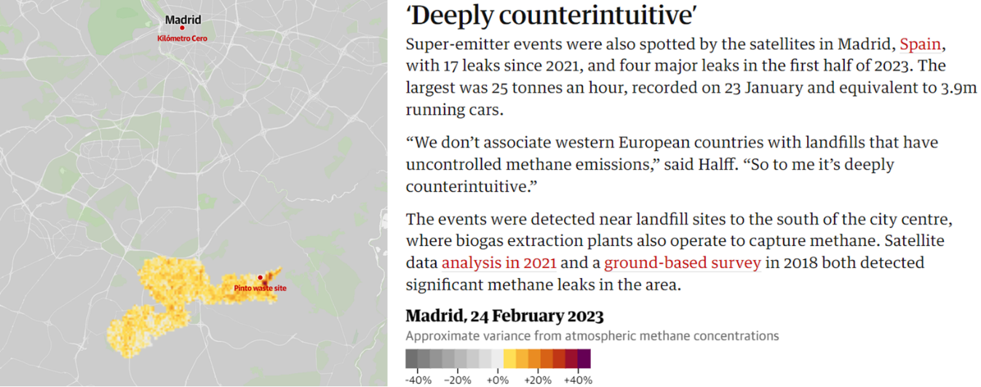

Figure 21: Article section from theguardian.com of CH4 emission near Madrid on the 24th of February 2024. The image was produced by Kayrros Methane Watch (The Guardian, 2024).

## 5.1 Sentinel-5 Atmospheric Gas Timeseries:

The Pinto Waste Site shown in figure 18 is not operated by PreZero but it has been added as Landfill 23. After running the S5-AGT tool, the CH4 emission can be seen to have occurred over 3 days from the 23rd to the 25th of February (figure 19).

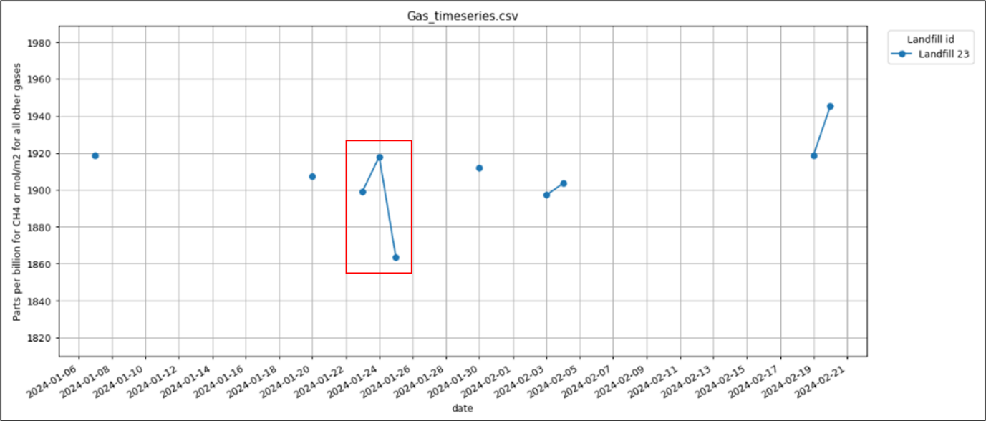

Figure 22: timeseries of test landfill 23 ‘Pinto Waste Site’, showing 3-day high methane levels highlighted in the red box.

To continue the assessment, the next tool visualises the CH4 data on a folium map.

## 5.2 Sentinel-5 Atmospheric Gas Concentration Map:

Once the S5-AGM tool has been run for the 24th of February 2023, it will display the atmospheric gas concentrations as shown in figure 20.

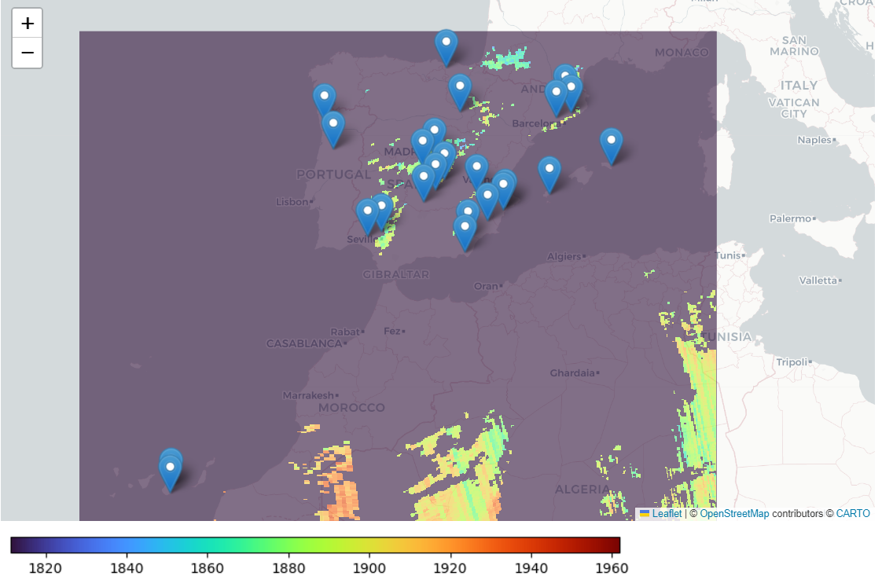

Figure 23: Screenshot of leaflet CH4 concentrations map, over Spain with landfill locations shown as blue pins.

The user can then zoom in to an area of interest. In figure 21 the Pinto Waste Site is shown along with a distinct hotspot of dark orange, characteristic of a CH4 plume (European Space Agency, 2021).

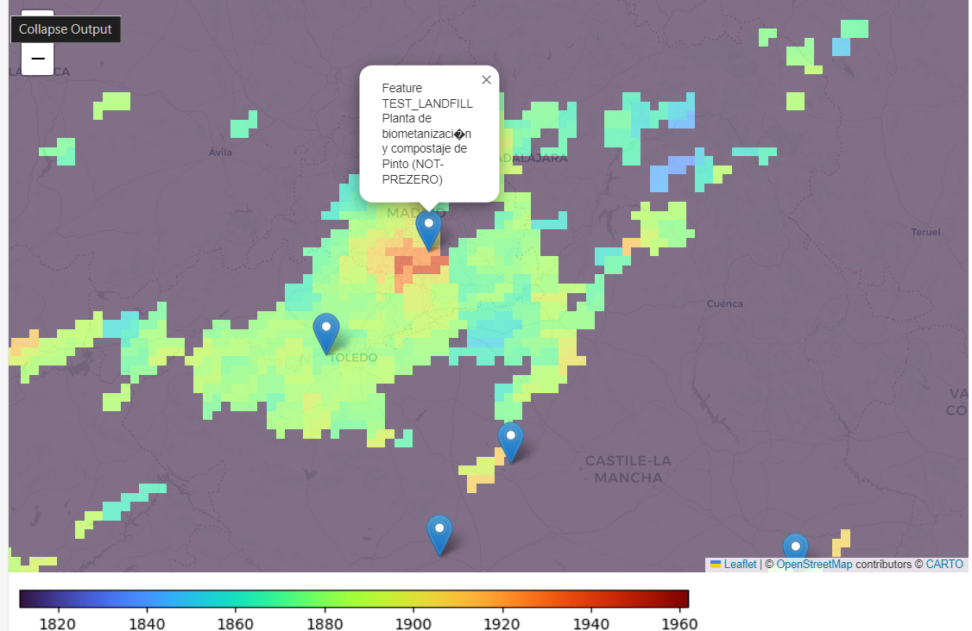

Figure 24: Close-up of Sentinel 5P data showing methane plume from

## 5.3 Sentinel-2 Multi-Band-Multi-Pass CH4 Map:

The S2-MBMP tool requires a ‘no emission’ date for comparison with the ‘active emission’ date. While ‘no emission’ is easily selectable by referring to S5-AGT, the peak emission date (24th Feb 2023) wasn’t available due to Sentinel 2’s return period (Sentinel Hub, 2024). However, data from the following day, was available.

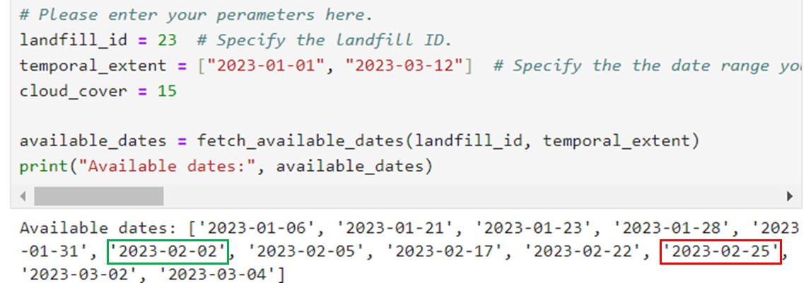

Figure 25: dates available tool showing dates chosen for emission (red box) and no emission days (green box).

The cloud filter should remove significant cloud cover that would interfere with the analysis. To be sure for this demonstration, the Copernicus browser was consulted for both datasets (figure 22), no cloud can be seen for either of the images.

|  |
| --- |
|  |

Figure 26: The scenes selected for the analysis as shown in the Copernicus Browser. Green highlighted box showing the no emission date, and the Red box, the active emission date.

Once the code is run using the small bounding box option, figure 23 should appear.

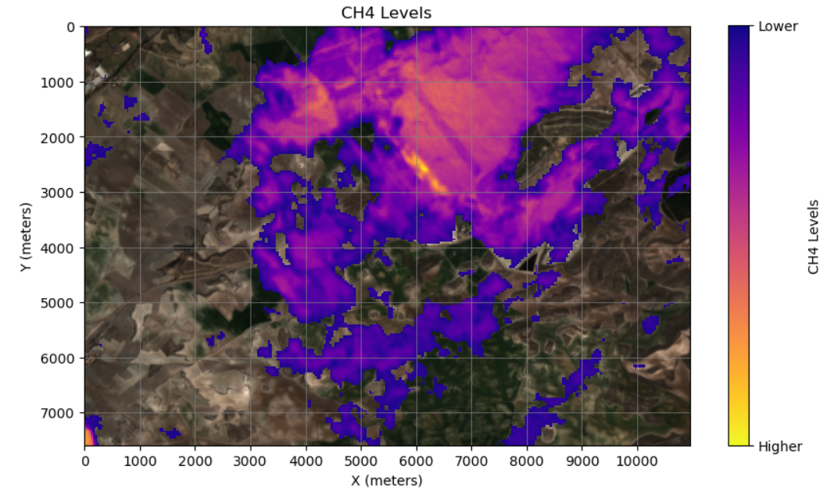

Figure 27: CH4 clouds over the Pinto Waste Site (small bounding box) on the 25th of February 2023, superimposed on a RGB satellite image.

If the large bounding box is selected then the following map should appear.

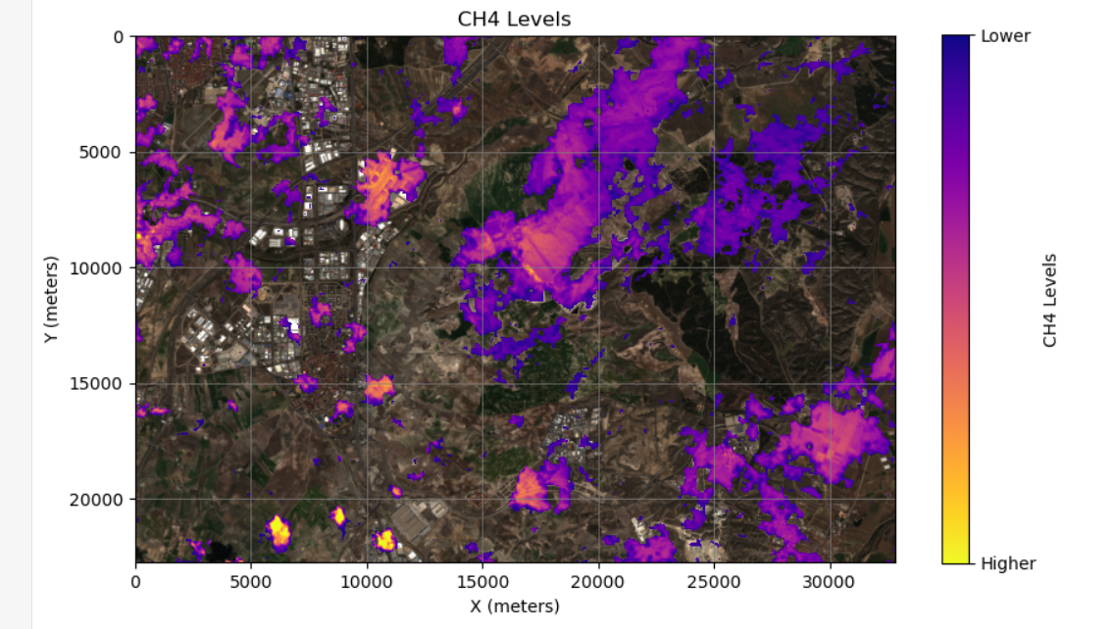

Figure 28: CH4 clouds over the Pinto Waste Site (large bounding box) on the 25th of February 2023, superimposed on a RGB satellite image.

Although the gas is somewhat dispersed at this stage in the emission event, the largest cloud is still squarely over the landfill in the centre of the image, indicating it is the likely source.

# 6. Troubleshooting

Input errors have been covered in the accompanying Jupyter notebook, however there are two errors unrelated to a user error which can cause problems. These are detailed below.

## 6.1 Remote disconnected error

|  |
| --- |
| Error: Remote disconnected |

This can occur when there are issues with the Copernicus network. In the event that you see an error like this you can check page <https://dataspace.copernicus.eu/news> for any downtime messages and you can also contact the Copernicus dataspace team via the form at <https://helpcenter.dataspace.copernicus.eu/hc/en-gb/requests/new>

## 6.2 Concurrent job error

|  |
| --- |
| OpenEoApiError: [400] ConcurrentJobLimit: Job was not started because concurrent job limit (2) is reached. (ref: r-240413b5d1b240118da9f9ed90807c58) |

This can happen when the tool is run, cancelled and then run again. If this happens the process is still running in the background and needs to be cancelled.

To do this go to the following URL: <https://openeo.dataspace.copernicus.eu/>

You will be presented with the following screen (figure 25). Please click the highlighted login button.

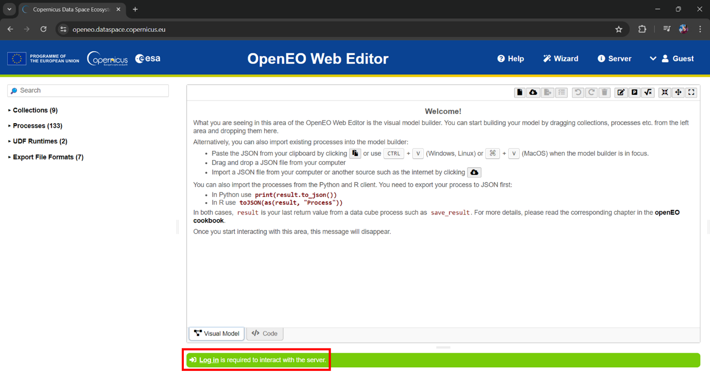

Figure 29: OpenEO Web Editor with login button highlighted in red

You will then see the following screen.

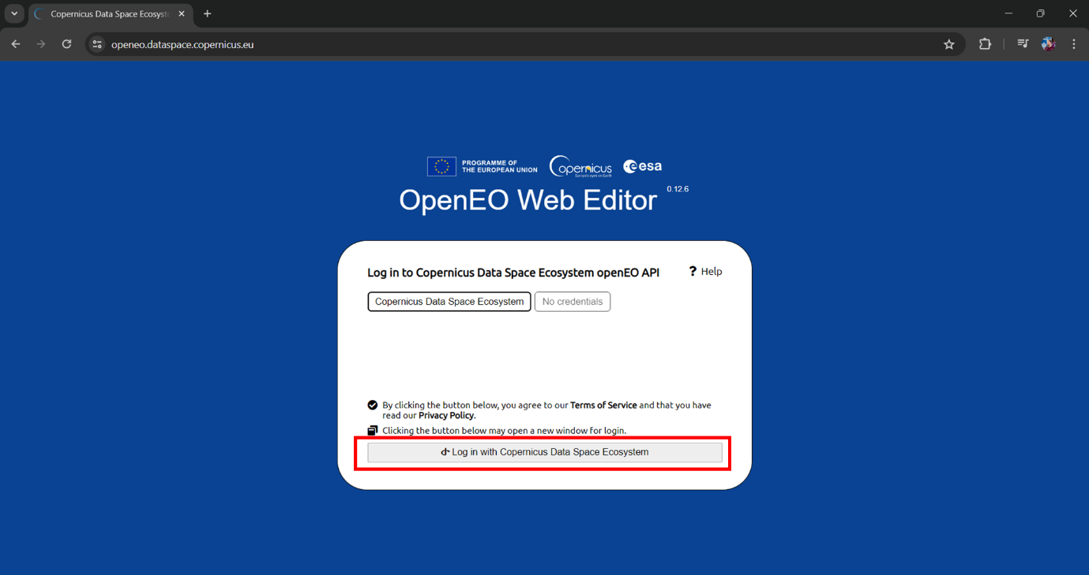

Figure 30: OpenEO Web editor login prompt with login button highlighted in red.

Simply click the highlighted button (figure 26) and follow the process. You should then be returned to the OpenEO web editor but now you will see a list of processes including the active ones.

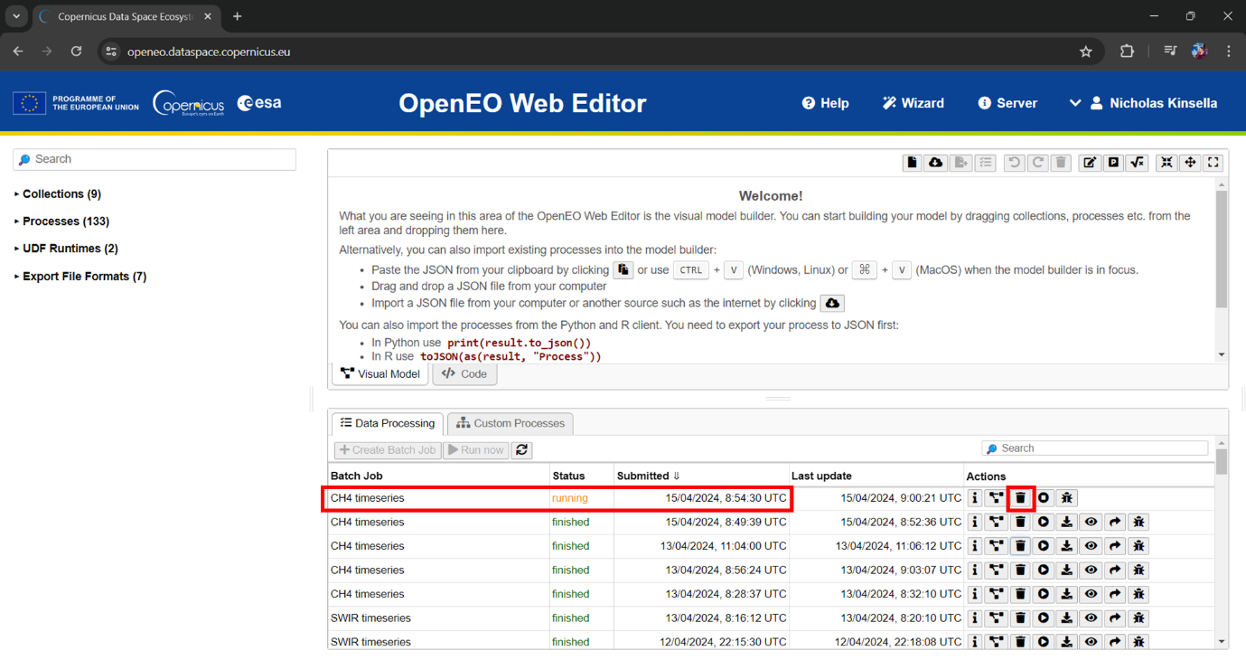

Figure 31: OpenEO Web Editor showing batch job screen, with running job and delete button highlighted.

To stop the process, simply click the highlighted bin button (delete). This should allow the tool to work normally again.

# 7. References

Aguasca, N. (2024). Zoom conversation with Nuria Aguasca from PreZero España, 9 April.

Amazon Web Services (AWS) (2023), Methane Emission Monitoring: GitHub, Retrieved April 30, 2024, from: <https://github.com/aws/amazon-sagemaker-examples/blob/main/sagemaker-geospatial/methane-emission-monitoring/monitor_methane_ch4_emission_point_sources.ipynb>.

Castillo-Giménez, J., Montañés, A., & Picazo-Tadeo, A.J. (2019). Performance in the treatment of municipal waste: Are European Union member states so different? Science of the Total Environment, 687, 1305-1314.

European Union. (1999). Council Directive 1999/31/EC of 26 April 1999 on the landfill of waste. Retrieved April 15, 2024, from: <https://eur-lex.europa.eu/eli/dir/1999/31/2018-07-04>

European Space Agency (2021) Satellites detect large methane emissions from Madrid landfills. Retrieved April 14, 2024, from: [https://www.esa.int/Applications/Observing_the_Earth/Satellites_detect_large_methane_emissions_from_Madrid_landfills](https://www.esa.int/Applications/Observing_the_Earth/Satellites_detect_large_methane_emissions_from_Madrid_landfills%20)

European Environment Agency. (2022). Early warning assessment related to the 2025 targets for municipal waste and packaging waste - Spain. Retrieved May 5, 2024 from: <https://www.eea.europa.eu/publications/many-eu-member-states/spain>

Ferronato, N., Torretta, V., Ragazzi, M., & Rada, E.C. (2017). Waste mismanagement in developing countries: A case study of environmental contamination. UPB Sci. Bull, 79(2), 185-196.

Hidalgo, M. (2024). Zoom conversation with Marcelino Hidalgo from PreZero España, 10 April.

Microsoft Copilot Designer. (2024). Cover artwork. Generated on May 5 2024, Available at: <https://tinyurl.com/45rr2h52>

OpenEO. (2024). NDVI Timeseries. [Online]. Retrieved April 22, 2024, from: [https://documentation.dataspace.copernicus.eu/notebook-samples/openeo/NDVI_Timeseries.html](https://documentation.dataspace.copernicus.eu/notebook-samples/openeo/NDVI_Timeseries.html%20)

Pandey, S., van Nistelrooij, M., Maasakkers, J.D., Sutar, P., Houweling, S., Varon, D.J., Tol, P., Gains, D., Worden, J., & Aben, I. (2023). Daily detection and quantification of methane leaks using Sentinel-3: a tiered satellite observation approach with Sentinel-2 and Sentinel-5p. Remote Sensing of Environment, 296, 113716.

Parker, R., Boesch, H., Cogan, A., Fraser, A., Feng, L., Palmer, P.I., Messerschmidt, J., Deutscher, N., Griffith, D.W., Notholt, J., & Wennberg, P.O. (2011). Methane observations from the Greenhouse Gases Observing SATellite: Comparison to ground‐based TCCON data and model calculations. Geophysical Research Letters, 38(15).

Salami, C. (2024). Zoom conversation with Carlos Salami from PreZero España, 10 April.

Sentinel Hub. (2024) "About Sentinel-2 Data." Retrieved May 5 2024, from: <https://docs.sentinel-hub.com/api/latest/data/sentinel-2-l2a/>

Sentinel Hub. (2024) "About Sentinel-5P Data." Retrieved April 23 2024, from: <https://docs.sentinel-hub.com/api/latest/data/sentinel-5p-l2/>

The Guardian. (2024, February 12). Revealed: the 1,200 big methane leaks from waste dumps trashing the planet. Retrieved May 1, 2024, from: <https://www.theguardian.com/environment/2024/feb/12/revealed-the-1200-big-methane-leaks-from-waste-dumps-trashing-the-planet>

Themelis, N.J. and Ulloa, P.A. (2007). Methane generation in landfills. Renewable Energy, 32(7), 1243-1257.

Varon, D. J., Jervis, D., McKeever, J., Spence, I., Gains, D., & Jacob, D. J. (2021). High-frequency monitoring of anomalous methane point sources with multispectral Sentinel-2 satellite observations. Atmospheric Measurement Techniques, 14, 2771–2785.

Vigano, I., Van Weelden, H., Holzinger, R., Keppler, F., McLeod, A., & Röckmann, T. (2008). Effect of UV radiation and temperature on the emission of methane from plant biomass and structural components. Biogeosciences, 5(3), 937-947.